Write a script that takes any number of directories as command-line arguments and then lists the contents of each of these directories.

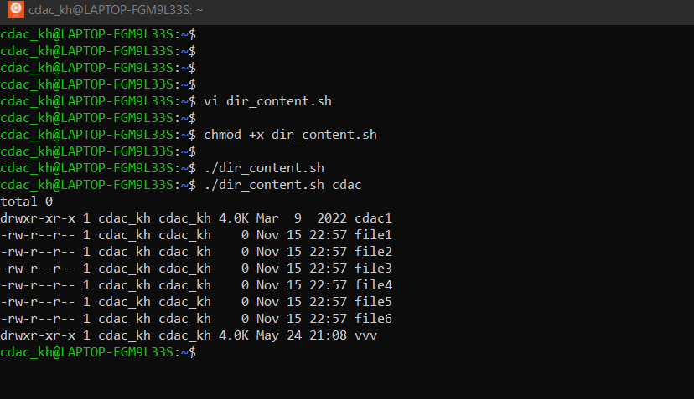

Display the names of any file-system which have less than 10% free space available

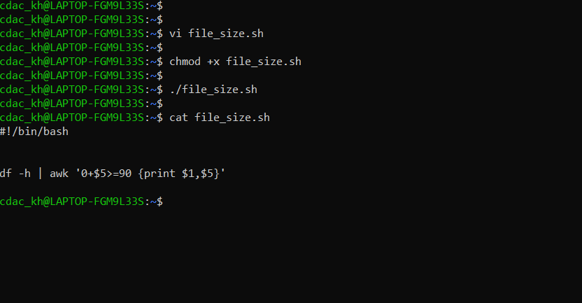

Q27. Script that takes any number of directories as command-line arguments and then lists the contents of each of the directories.

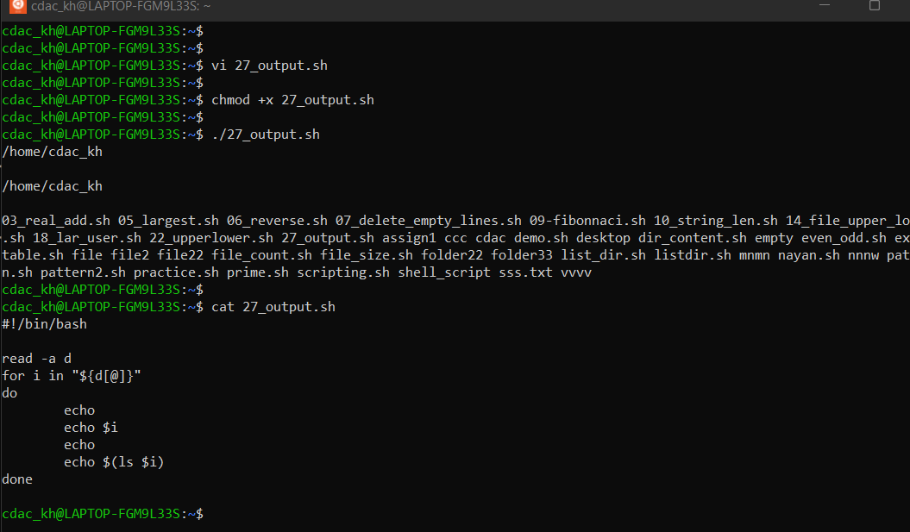

Q13.  Script to print the following:

        • Currently logged users

        • Your shell directory

        • Home directory

        • OS name & version

        • Current working directory

        • Number of users logged in

        • Show all available shells in your system

        • Hard disk information

        • CPU information.

        • Memory information.

        • File system information.

        • Currently running process

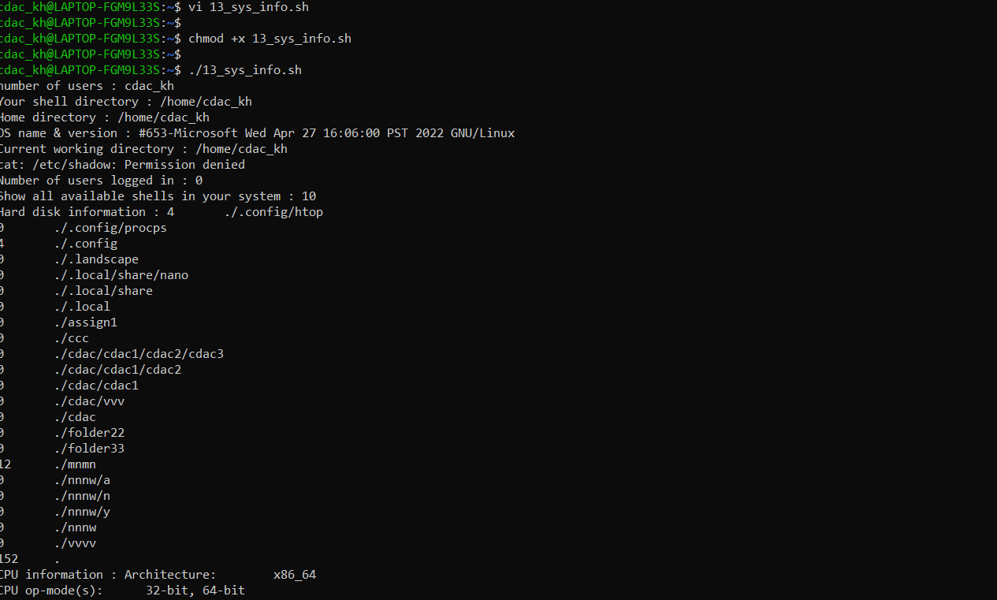

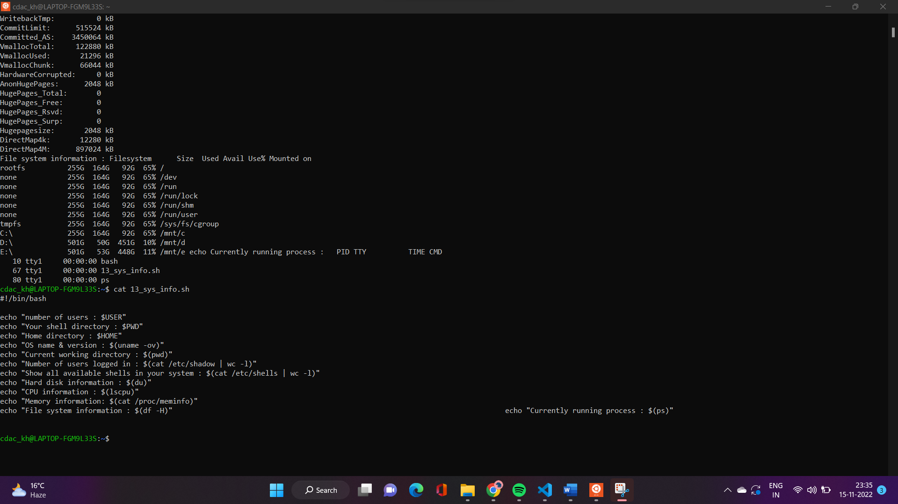

Q15.

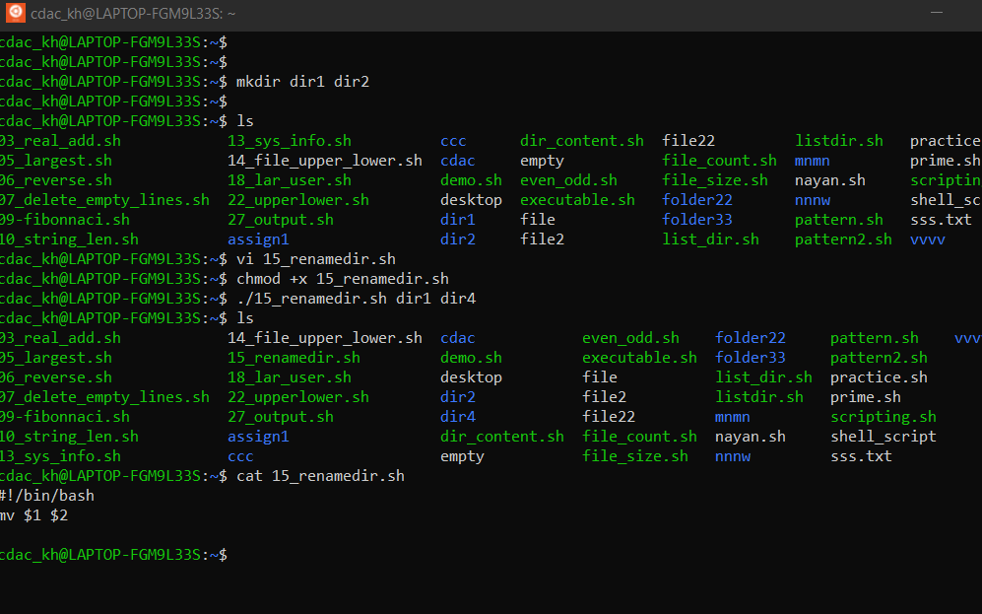

Q11.

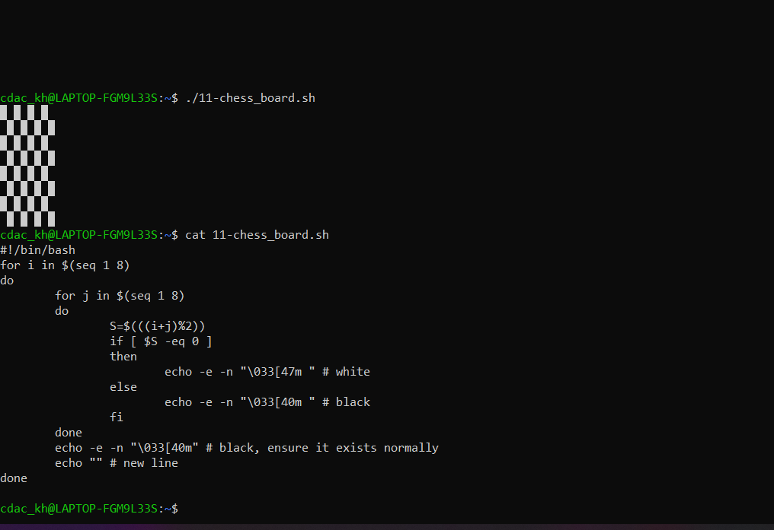

Q17.

